TIME SERIES DATA ANALYSIS AND FORECAST METHODS

Lecture 1
Time series definition and typical models

Yekaterinburg
2017
Contents

Lecture purpose 3

Lecture map 3

Part 1. Time series definition 4

Part 2. Time series classification 7

Part 3. Typical time series models 13

References 16

Lecture purpose
The purpose of this lecture is to introduce students to a concept of time series, to their key types and models, to the definition of stationarity in narrow and broad meanings, and also to form the abilities and skills for application and estimation of standard models for the majority of time series data, based on their classification.

Lecture map

- Time series definition
- Time series analysis problems
- Time series classification
- Stationary and non-stationary data, ergodicity definition
- Typical time series models
- Principal components of those models

Part 1. Time series definition
Time series − the arranged sequence of the observation results of the current values of one or several parameters recorded in consecutive instants. Mostly these indicators are arranged in a chronological order. A number of currency rates of EUR/USD (fig. 1.1) can be the simplest example of a similar time series.

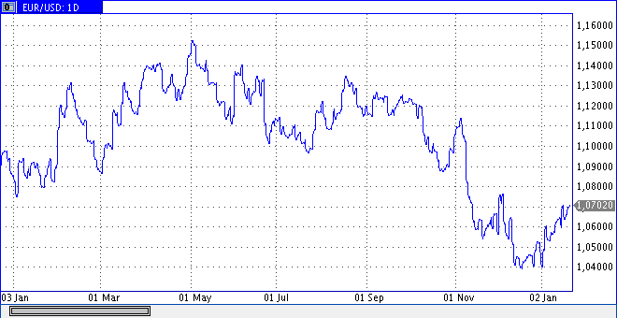
Figure 1.1 – The time series representing counting of an indicator of a course of the relation of currencies of EUR/USD (euro to US dollar)

From the point of view of probability theory the time series represents selection of a universe of some stochastic variable, the characterized certain distribution function. To understand this phrase, present that there is some process, whether it be physical or social and economic, and it has accidental character and is reflected in type of the sequence of stochastic variables 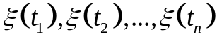, where 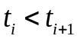. Then set of observations 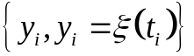 in instants 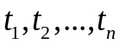 will be called time sample. What's the difference between these two concepts? The matter is that this set of observations is not accidental any more, it is already recorded and exists in singular. But on these observations in a problem of adaptive data analysis we also try to evaluate initial accidental process. Further under a time series (TS) we will understand this temporary selection, but at assessment of its parameters including relying also on the unknown stochastic variable which is its cornerstone.
Changes of a stochastic variable 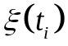 happen under the influence of the most various factors and the reasons often hidden from the potential observer. Therefore concerning TS the assumption is made that cumulative influence of factors creates some pattern in evolution of a row. Search of this pattern by different methods also represents process of time series analysis. When similar pattern is found, creation of a row will become possible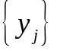, which we did not observe yet, but we plan to see. Such process of creation of future observations on the basis of the found pattern and analyzed by TS will be called then process of forecasting of time series.

At time series analysis it is possible to select three primal problems:
- Determination of quantity characteristics of the process which generated given TS which will allow us to understand the nature of the hidden stochastic variable;
- Quantitative comparison of TS with each other for detection of similarities and distinctions between processes by which they are generated;
- The description of formal models which could describe evolution of development of process which generated given TS;
- Decomposition of TS on elementary components, which then it is possible to analyze according to tasks from three previous points.

Thus, it is necessary to remember that the fixed observations of TS were generated by some accidental process, but as they are continuously connected with each other, on observations it is possible to try to evaluate this initial accidental process. As we will see further, the task considerably will become simpler if a part of initial process can be defined as determined (that is such that unambiguously is defined depending on factors and a present situation of time), and a part – as is pure stochastic (defined through distribution of eigen-function). Search of such splitting is the simplest both efficiently the analysis and, at the same time, forecasting now time series. Really, by determination of the determined component, on its basis it will be possible to build the forecast, and the accidental component will give us all those necessary statistical characteristics of the initial accidental process which generated TS.

Part 2. Time series classification
For any given time series , where , it includes two obligatory parameter: the time and the specific value at this point 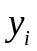, called observation, level or reading. Apparently, from a combination of types of these two indicators basic classification of time series will be defined. Also still it is necessary to consider features of the most initial process which can significantly limit us in opportunities of its analysis. In general classification of TS is given in table 1.1 below.
Table 1.1. Time series classification
Classification type | Time series types
Type of data, levels, observations | - Absolute values TS  - Relative values TS  - Mean value TS
Type of time frame | - Equidistant TS  - Unequally-spaced TS
Type of function between observations and time frames | - Interval TS  - Instantaneous TS
Type of generating stochastic process | - Stationary TS  - Non-Stationary TS = NS TS

Let's consider these classifications in more detail. The first type of classification is the simplest: observations are fixed or just in the form of some absolute value (in kilograms, meters, pieces, etc.), or in the form of the relation of two values of one dimension (see the figure 1.1 EUR/USD), or are observed constantly with a small time frame (for example, every day/hour), but are fixed only in a type average values for larger period (values averaged monthly/annual average, etc.) as the main nature of process is defined by large-scale factors.
The second type of classification is more difficult. Equidistant TS form at a research and fixing of values of process in the following one after another regular intervals of time. That is for set temporary grid 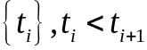, value 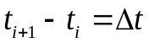is a constant. Majority of real processes are described equidistant time series – just because it is simpler to analyze them, and they have higher accuracy of methods of calculation of their characteristics. Unequally spaced TS do not carry out the principle of equality of intervals of a temporary grid, that 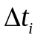 changes. It is much more difficult to analyze such ranks as the theory of the analysis of similar is much more poorly fulfilled by TS in practice, and the accuracy of calculation of their characteristics decreases. There are two reasons of use of a similar inefficient class of TS in practice. First, because of the nature of the most initial process: for example, all market indexes fix only in the working days of week. Secondly, because of a method of fixing of counting of TS: for example, in medicine the majority of the processes proceeding in a body of the person arises spontaneously, and doctor fixes them upon emergence, tying to a time grid counting.
The third type of classification in something is similar to the first. Interval TS represents the sequence in which the absolute level of a row is referred to the result which is saved up or again made for a certain interval of time. For example, a number of an indicator of production by the enterprise in a week, month or year is interval; volume of the electric power made for hour, day, month and others. Moment TS are characterized by specific instants when these indicators were recorded. Examples of moment ranks are sequences of financial indexes, market prices; physical indicators, such as ambient air temperature, humidity, pressure, measured in specific instants, and others.
The fourth classification is the most difficult for understanding, but at the same time will be also the most important. Depending on type of TS on this classification it will be essential to change type of the used models, analysis technique of TS in general, means of the forecast, etc. Moreover, adaptive means of time series analysis belong to the class of the non-stationary time series (NSTS) as historically need for their creation arose from a similar class of tasks. Let's give at first strict mathematical definitions of these types of TS, and then we will try to understand them from the point of view of practice.
Stochastic process is strictly stationary (or stationary in a narrow sense) if its multidimensional probability density
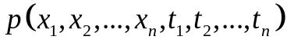
of any dimension n does not change at simultaneous shift of all time axis on the identical value :
(1.1)
If to limit requirements to that only one-dimensional and two-dimensional probability densities did not depend on temporary shift, then such accidental process call stationary in a wide sense. At accidental process stationary in a broad sense mathematical expectation and dispersion do not depend on time, and correlation function depends only on an interval of a temporary grid:
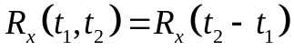.
Any time series which are generated by accidental processes for which the stationarity condition even in a broad sense are not satisfied, are called the non-stationary time series (NSTS).
With stationarity definition we still need the subclass of stable accidental processes called ergodic stochastic processes.
Stationary stochastic process is called ergodic, if any of its statistical characteristics calculated by averaging on a set (ensemble) of implementations are equivalent to the similar characteristics calculated by averaging on time of one, theoretically infinitely long, implementations.
Let's understand why these two concepts are so important for the analysis of TS: stationarity and ergodicity.
Let's remind that any row is only discrete sample from some universe of an stochasatic variable. That is, we on hands have only one copy of TS which besides has limited length on time, and the number of counting is fixed. Majority statistical, correlation and regression methods rely on different basic theorems and determinations from probability theory. In it statistical characteristics of stochastic variables always average on ensemble (for example, the same Monte-Carlo method is based on this principle). On the other side of TS exists only in the single copy, we have no such set of rows that on them to average something. But, entering a concept of ergodicity, we can replace averaging on ensemble with averaging on time that saves us from need to generate additional selections of the set accidental process.
Various statistical criterions and spectral/correlation methods more depend on stationarity of TS. It is connected with the fact that key algorithms which are under construction in similar techniques always make a start from initial assessment expectation value and dispersions. In this or that form both of these statistical values participate in calculations and to check of statistical hypotheses in the form of constants. And a consequence of determination of stationarity of accidental process in a broad sense also is just the fact that expectation value and dispersion are fixed and do not depend on time. Then for non-stationary processes it turns out that their expectation value and dispersion will be functions from time. More precisely, in dependences on that interval of time of TS on which we evaluate these statistical characteristics their result will change, that is characteristics of process will depend on a reference mark. For a solution of this problem we or should look for such interval of time on which we could consider a row quasi-stationary, or use methods which do not demand assumptions of stationarity of TS at all. Similar methods of the analysis of NSTS just call adaptive: they adapt, change the algorithm and parameters depending on the row, and adapt all those values that were considered as constants, to some functions from time, just as expectation value and dispersion are functions from time for NSTS. From here it is necessary to understand that all results received during the analysis of NSTS by adaptive methods will always be presented in the form of some functions from time, which is in the form of instant values.
It is necessary to understand that in practice most TS are non-stationary while stationary cases are best of all described and fulfilled. It is much simpler to describe and analyze stationary time series, and, the most important, to predict therefore in the analysis of any of TS at first try to evaluate whether it is stationary in a broad sense, and then select a technique of its analysis.
Once you note that pure theoretical determination of stationarity of accidental process (and in narrow, and in a broad sense), is not applicable in practice. Really, by determination (1.1) to prove that TS is stationary, we should touch all possible shifts time frame (that is all possible reference marks). In practice use other approach: initial TS is checked by means of certain statistical criterions (for example, KPSS-test) for a hypothesis of stationarity of this row. In this case TS will be not absolutely precisely стационарен or not but only with some fiducial probability that allows to evaluate as far as we are close to theoretical extended sense of stationarity how correct the solution to use methods of the analysis of stationary time series is. It is clear, that from this point of view, it is better for TS to consider everything initially non-stationary and to use only adaptive methods for their analysis. But the accuracy of these methods as we will see further, will always lose to similar methods, relying on the assumption of stationarity of accidental process, the cornerstone studied row.
Thus, once again we will remind that all classification of TS can be reduced to the following scheme (fig. 1.2):
Time series
Type of data, observations
Type of
time frame
Type of function between y & x
Type of stochastic process
Absolute value TS
Relative value TS
Mean value TS
Equidistant TS
Unequally-spaced TS

Interval TS
Instantaneous TS
Stationary TS
Non-stationary TS
Figure 1.2 – Time series classification

Part 3. Typical time series models
Any time series data is generated by some stochastic process. It can be described in several ways: through its distribution function and other statistical characteristics, or having constructed for it some mathematical probability model. The first method of the description is well formalized conceptually, but badly is suitable for the description in the form of some computer program. The second method is much better formalized in the form of the program and therefore, is closer for perception by the person. For this reason for the analysis of TS of real processes of the different nature different models of time series are actively applied.
One of the main classes of models of time series is the class of additive models of a type:
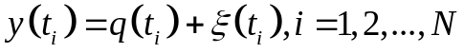 , (1.2)
where 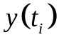 – TS observations, 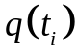 – deterministic (non-random) component, which in itself can be presented by some complex model, – stochastic component о time series.
Such model has a set о benefits, but the most from them, it is the fact of separation of initial model into two components: deterministic and stochastic. The deterministic component can be used for a forecast purposes or for a clear description о generating process. By varying this type of component it is possible to receive a whole family of different models suitable to each specific objective.
The stochastic component can carry every other accidental factor influencing the studied process irregularly. This component still sometimes is called a residual data as at first we always select the determined component, and everything that did not enter it – by determination of the term, will be random. If an initial task of the analysis of TS is forecasting, than the stochastic component often called the noise, as it only interferes with the effective forecast. Anyway, accidental a component is an obligatory constituent of any of TS as a row is only one selection of the general universe of some accidental process, and uniqueness of this selection is defined by specific implementation of this components.
Various methods оf decomposition о the deterministic component into different parts define a set of subclasses or family of models for time series. In general, all these models come down to the following expression:
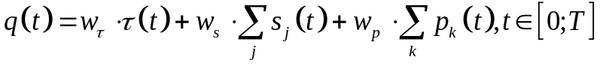 , (1.3)
where 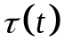– trend ( or tendency); 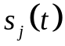– j seasonal component, in any model there can be several о them (monthly, quarter, yearly, etc.); 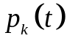– k periodic (cycle) component, in any model there can also be several оf them; 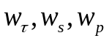 – coefficients of presence or lack of components, can be in values оf 0 or 1.
The trend represents steady pattern, observed during a long interval of time. Usually the trend is described by some simple monotone function from time, or comprises generally all low-frequency components of the analyzed row.
The season linked with existence of the factors, operating with some periodicity. These are regular quasi-periodic fluctuations and oscillations multiple of a temporary grid. Typical examples of seasonal components are monthly, the quarter, annual, and other repeating events. Seasonal a component it is always connected with real factors of seasonality from real life: surges in purchasing power are connected with holidays, season influences seasonality of goods, time of maturing of food defines their quantity, etc. Seasonal components can be a little, they often are multiple among themselves, as well as in real life. The important characteristic of the seasonal component is the fact that they can change over time, that is have floating character therefore they are quasi-periodic. They can change their amplitude modulation, phase shift, or even the period of a season can float near some average value.
Periodic (cycle) component is a nonrandom function describing the long periods of change of cycles of variable length and amplitude. Unlike a season the cycle has the fixed trigonometric component, the reflecting some cyclic changes in the initial analyzed process.
Now seasonal and cyclic components almost do not distinguish from each other. In many modern analysis techniques of TS seasonal components call quasi-periodic components of the small period, with floating characteristics while long-term periodic components are called cycles which are much steadier against change of the characteristics. Everything that does not enter these two trigonometric components of the determined model, apparently from expression (1.3), usually take for a trend. In this case the trend may contain also the long-term periods / tendencies, but they then just are not considered important for the analysis and forecasting of this specific process.
Along with additive models (1.2) there are also multiplicative models:
. (1.4)
Besides there is also a special class of the combined models, in which there is both an additive part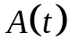, and multiplicative part 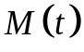:
(1.5)
Other important subsets of models which will be considered in more detail later are so-called autoregressive models:
(1.6)
where function f reflects the nature of interrelation between the subsequent and previous values of TS, and function g reflects the interrelation of the subsequent values of TS from the previous noise. For a wide range of processes both of these functions f and g have linear character, we call such models the linear filter:
(1.7)

References

1. Box G., Jenkins G. Time Series Analysis: Forecasting and Control. — 4th ed. Wiley. — 2008. — 784 p.
2. Robert H. Shumway, David Stoffer. Time Series Analysis and Its Applications. — Springer Texts in Statistics, 4th ed. — 2016. — 550 p. ISBN 978-3-319-52451-1
3. David R. Brillinger. Time Series: Data Analysis and Theory. — SIAM. — 2001. — 540 p.
4. Karter J. Time series analysis with MATLAB. ARIMA/VARMAX/ GARCH/GJR Models. Functions and Examples. — 2016. — 422 p. ISBN 978-1-539-54638-2.

